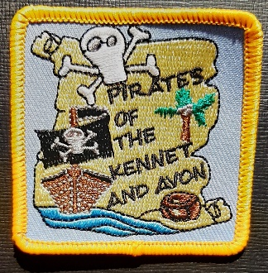
JOIN US FOR OUR THEMED
NARROWBOAT PIRATE DAYS
On the Kennet and Avon Canal
Just £23 per Child and £5 per Adult*
For a full day on our narrowboat.
Learn to drive the boat and work the locks.
Price includes a fully skippered day onboard.
Drinks, snacks, themed crafts, and a badge.
No experience needed

Thurs 11th Aug – Aldermaston – Newbury
Friday 12th Aug - Newbury – Hungerford
Saturday 13th Aug - Hungerford – Great Bedwyn
Thursday 18th Aug - Bradford on Avon – Bath
Friday 19th Aug - Bath – Bradford on Avon
Tuesday 23rd Aug - Great Bedwyn – Hungerford
Wednesday 24th Aug - Hungerford – Kintbury – Hungerford
Thursday 25th Aug - Hungerford – Newbury
Friday 26th Aug - Newbury - Aldermaston

e-mail myersj@hotmail.co.uk for more details

*based on 8-10 Brownies, Guides or Rangers plus 2 adults

