LADY HILDA
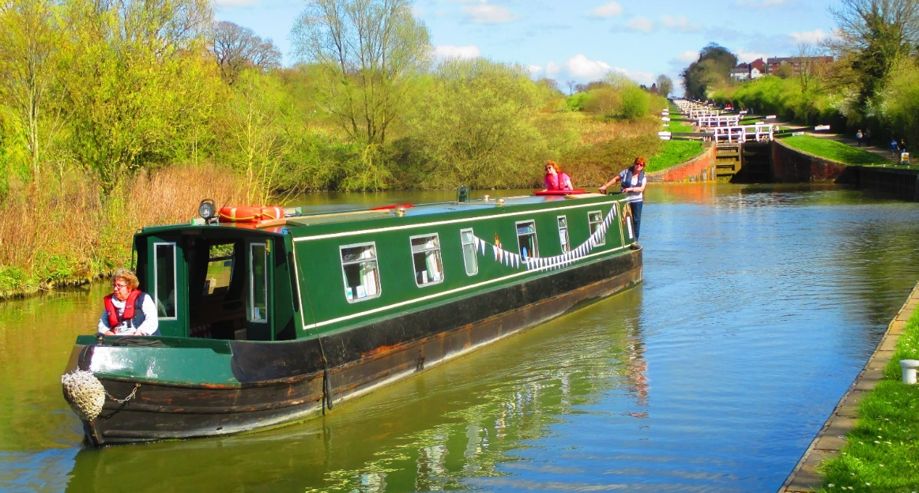
Lady Hilda at The Devizes flight
Lady Hilda is a 62’ narrowboat based at Great Bedwyn and run by the Bruce arm of the Kennet and Avon trust.
There is free parking onsite or Bedwyn train station is just 5 mins walk away.
She sleeps 9, 7 on bunks and 2 in the living room.
She has a fully equipped kitchen, two bathrooms, one with shower and toilet the other with a toilet and sink
There is a sitting/dining area and room to sit on the bow and the stern.
A weekend (fri evening to sun evening) costs £240. One day at the weekend is £170 or during the week, £120. A week is £700. To this you would need to add your food, craft and any badges you might want.
A qualified skipper is needed but we are usually able to provide one if needed.
A usual weekend trip would take you to Kintbury or Hungerford and back or to Wooton Rivers and back. A day trip would be to Kintbury or Crofton and back. Hirers are expected to leave the boat clean at the end of their trip.
Longer trips can be arranged (if a skipper is available)
For availability see https://bruceboats.katrust.org.uk/youth-groups/
To book with a skipper please email myersj@hotmail.co.uk
To self skipper you would need a Girlguiding or CCBM qualification.
To book the boat please email bookings@katrust.org.uk or ring 01380 721279
Please follow us on our Facebook page, Lady Hilda – youth and community narrowboat

