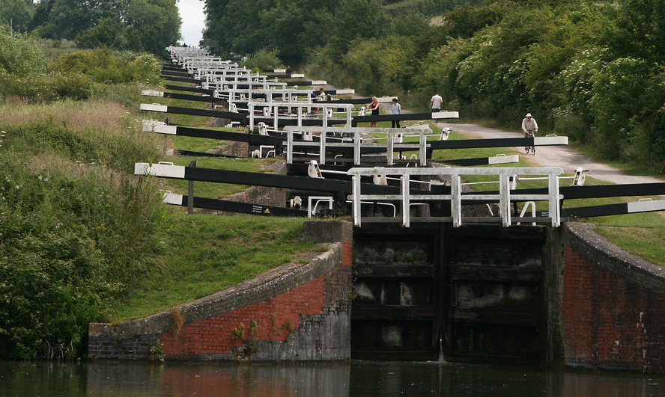

Caen Hill Locks
2022

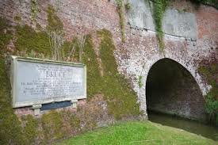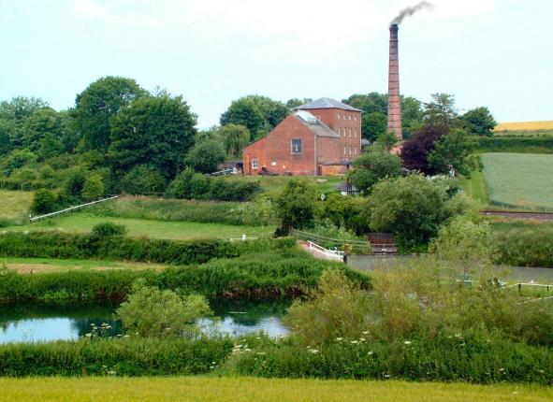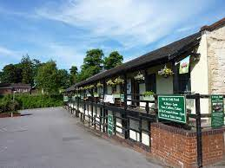
The Bruce tunnel and summit Crofton pump house Devizes canal museum

Here is one for the bucket list…
These trips are for Guiders on-board Falcon Adam, a 70’ narrowboat.
Great Bedwyn – Bradford on Avon – 15th – 17th August 2022 (going down)
Or
Bradford on Avon – Great Bedwyn - 20th – 22nd August 2022 (going up)
£110 per person to include all food and accommodation, a trip to the Kennet and Avon canal museum and Crofton pump house, and a badge… and of course 3 whole days of boating taking in the Caen Hill locks and the Bruce tunnel.
Email Julie at myersj@hotmail.co.uk for more details or to book a place.

