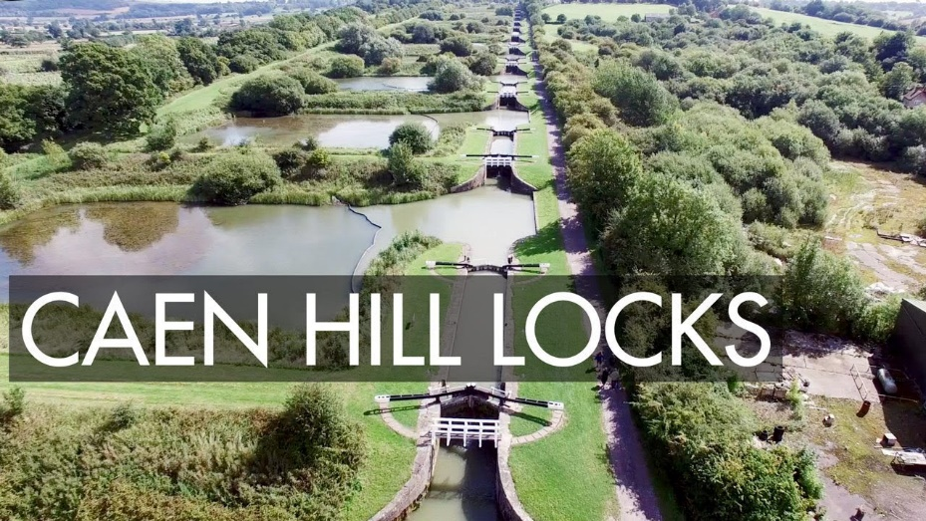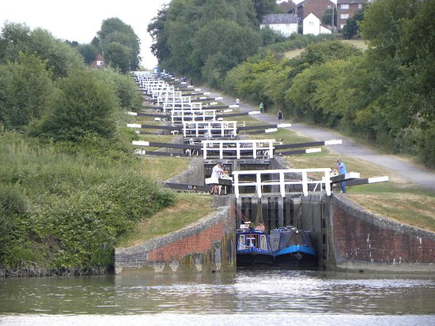
Caen Hill Locks adult narrowboat trip
Here is one for the bucket list…
The trip is for adults only on-board Lady Hilda, a 62’ narrowboat.
Thursday 30th July at Bradford on Avon to Sunday 2nd August at Great Bedwyn
£115 per person to include all food and accommodation (apart from one meal out), a trip to the Kennet and Avon canal museum, and a badge… and of course 4 whole days of boating taking in the Caen Hill locks and the Bruce tunnel.
Email Julie at myersj@hotmail.co.uk for more details or to book a place.

